Unfreezing Exercise 3: Define/Redefine STEAM Learning Goals in Your School
1) Discuss & Debate: Along with your fellow educators and stakeholders in the school, discuss the following:
- What are the hopes, aspirations and dreams that your community has for young people?
- What are the skills and habits of mind that students need for success in this rapidly changing and complex world?
- Are our students well prepared to contribute and compete in this global, innovative economy?
2) Review & Analyse: Review the examples shown below of how some US education institutions define the 21st-century learning goals. What do you think about it? What would be most relevant and meaningful to your school and your students?
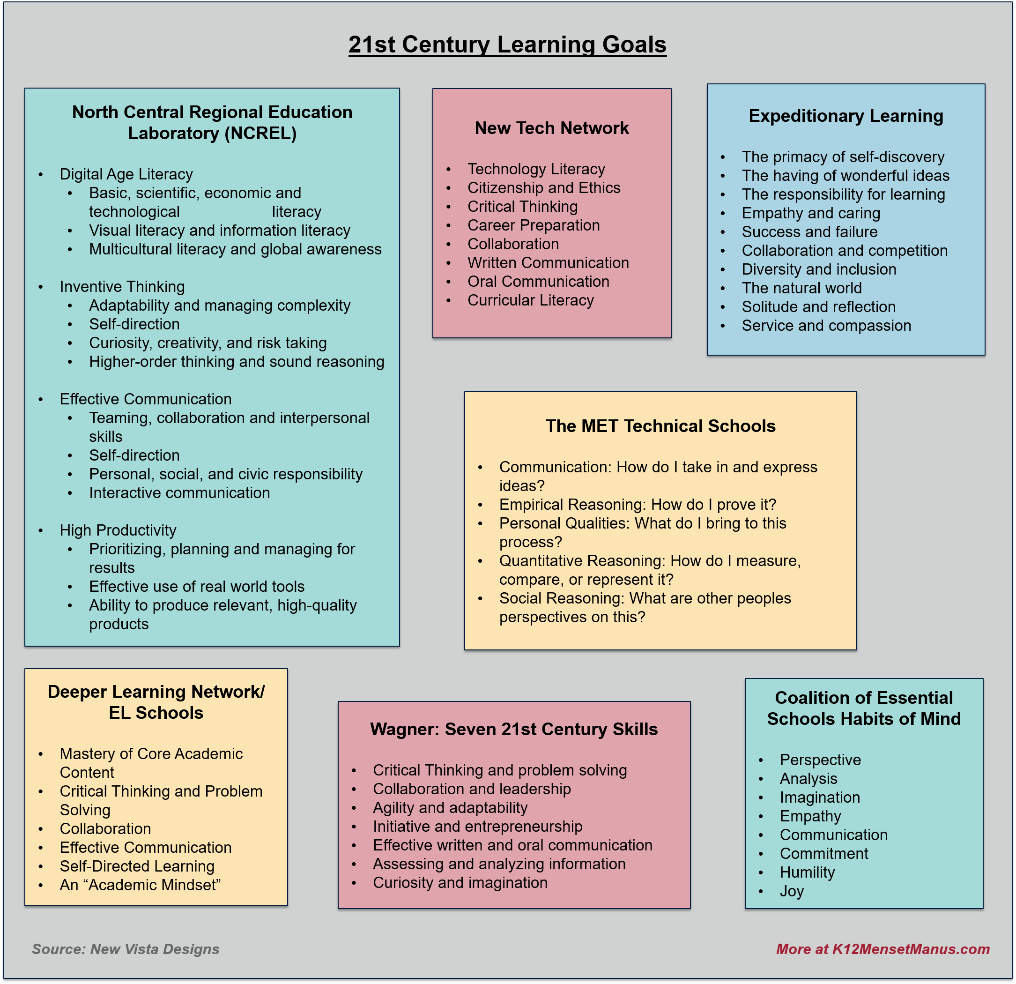
3) Brainstorm & Design: Brainstorm about the learning goals/ competencies that you believe students from your school should have upon graduation. Prioritize a set of competencies (around 4-6) to form a “Portrait of a Graduate” of your school
4) Adopt & Accelerate: Adopt the Portrait as the key driver of strategic planning of your school, bearing in mind the implications of such design for the learning experiences provided in your school.

