Unfreezing Exercise 4: Value Stream Mapping (VSM) on Your School's STEAM Offering
Workshop Preparation:
- Define the core process to focus on (e.g. “STEAM learning opportunities offered to students in their 6th grade”)
- Identify a VSM workshop facilitator (either internal or external) and champion, who will work together to build a workshop charter including:
  - Problem statement
  - Specific goals and deliverables
  - Attendee list
    - Tip: Be sure to include as many relevant stakeholders as possible, including a fair representation of different subject teachers and school administration
  - Logistics: timing, location, deadlines, technology and/or supplies
    - Tip: Post-it notes, flip chart paper and whiteboards are found to be very useful materials when conducting a VSM workshop
- Ensure that all workshop attendees understand what VSM is, its benefits and how it can be used prior to joining the actual workshop
- Invite a small group of representatives to do a first pass of the VSM to fill out the steps in their swim lane of the overall process (e.g. “Defining the learning opportunities in their subject that is relevant to STEAM throughout the academic year”)

During the workshop
1. Map out the current state
- Using post-its and markers, each group (e.g. teachers teaching the same subject) should review and edit the first pass of the VSM done by the representatives
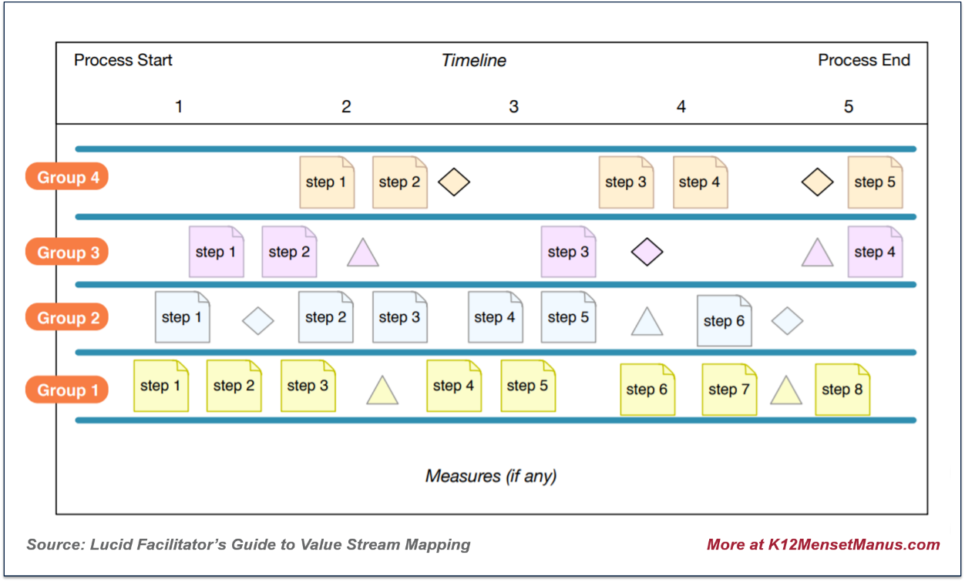

2. Brainstorm and map the future state
- Each group should present the VSM that they have created and invite everyone to identify problems, issues, misalignments, waste or lost opportunities
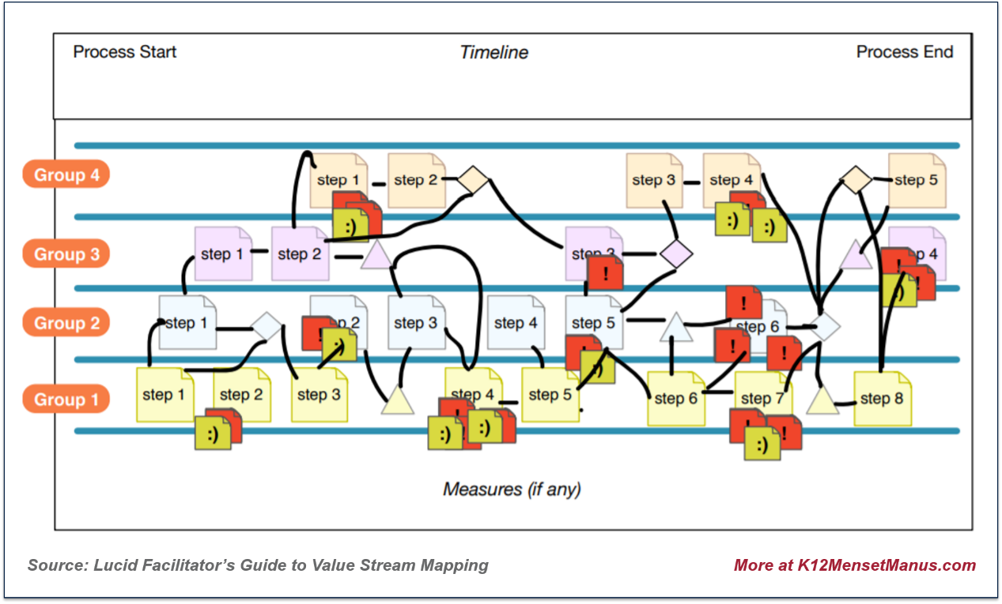

3. Identify dependencies across different groups and brainstorm improvement opportunities
